**Ex no:5 210701511**

**Createtablesin Hiveand writequeriesto accessthedatain thetableAim:**

TocreatetablesinHiveandwritequeriesto accessthedatainthetable.

**Procedure:**

**HiveDownloadand installation:**

1. HiveInstallationsetup:

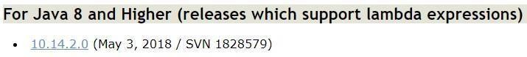- Download and install Apache Derby version 10.14.2.0: [https://db.apache.org/derby/derby_downloads.html#For+Java+8+and+Higher](https://db.apache.org/derby/derby_downloads.html#For%2BJava%2B8%2Band%2BHigher)

-DownloadandinstallApacheHiveversion3.1.3: <https://downloads.apache.org/hive/hive-3.1.3/>

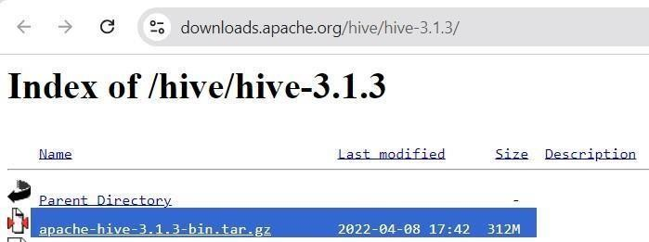

1. Addenvironmentvariables:

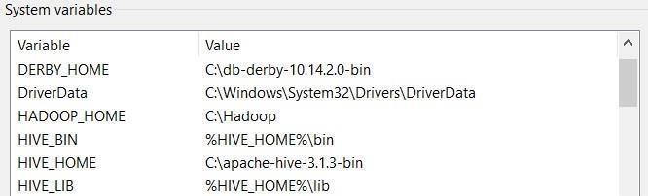Environmentvariables >Systemvariables>Addthebelow paths

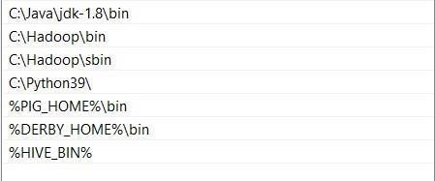->(Inside Path)

1. CopyDerby libraries:

GototheDerbylibrariesdirectory(db-derby-10.14.2.0\lib)andcopyall*.jarfiles.Then, paste them within the Hive libraries directory.

1. Configuringhive-site.xmlandHive’sBinfolder:

Referfollowinglinktodownloadthefile.Alsodownloadtheguavafile.Puthive-site.xmlfileto hive’s conf location and replace hive’s current guava file with this one in lib location. Also download the bin folder from link and replace the existing hive’s bin folder.

https://1drv.ms/f/s!ArSg3Xpur4Grmw0SDqW0g44T7HYU?e=wDsoBn

1. StartingHadoopServices

OpenPowerShellasadministratorandgotoHadoopsbindirectoryandstarthadoop services using the following commands:

Start-all.cmd

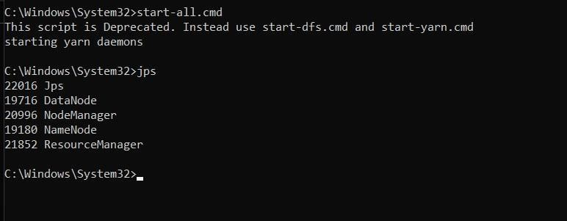

1. DerbyNetworkServer:

OpenanotherPowerShell windowandrunthefollowingcommandtoopenDerby:

StartNetworkServer-h0.0.0.0

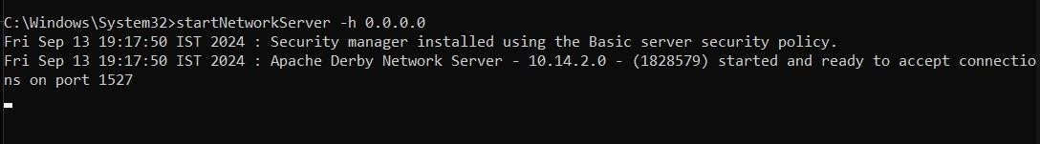

GotofirstPowerShellwindowandcheckwhetherNetworkServerControlisrunning.

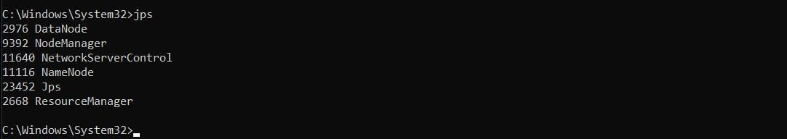

1. StartingApacheHive:

GotoApacheHive’sbinlocationwithcdcommandandrunthefollowingcommand:

hive--serviceschematool-dbTypederby–initSchema

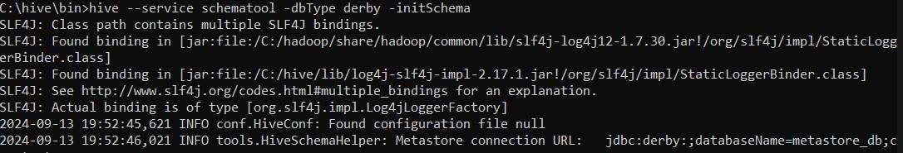

1. OpenHiveshellbytyping:

hive

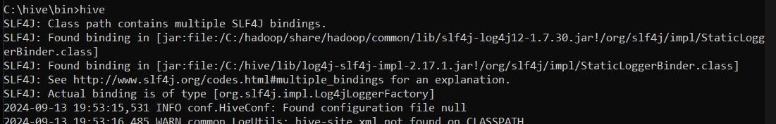

**CreateaDatabase:**

Startbycreating adatabase.Open theHiveCLIandfollow thesteps below:

1. Usethe**CREATEDATABASE**statementtocreateanewdatabase:

CREATEDATABASEmydb_1;

1. Verifythedatabaseispresent:

SHOWDATABASES;

1. Switchto thenewdatabase:

USEmydata;

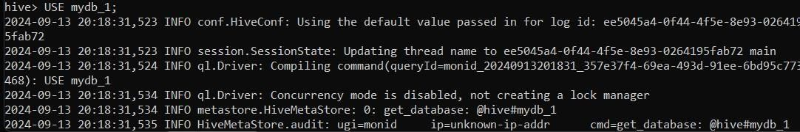

**CreateaTableinHive:**

CREATETABLEstudents_table(nameSTRING,rollINT,deptSTRING);

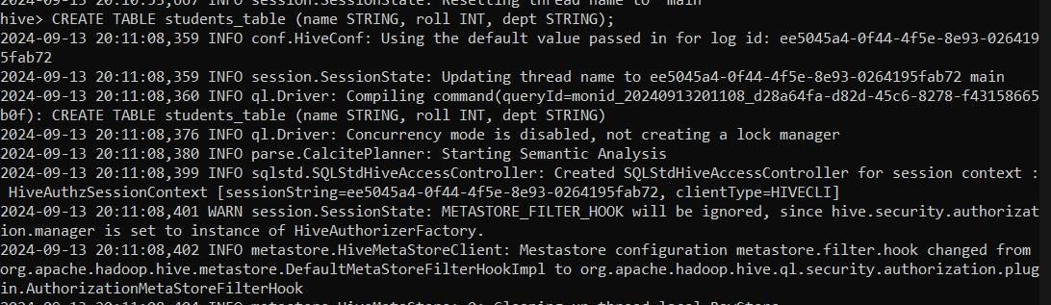

**Createa.csvfile:**

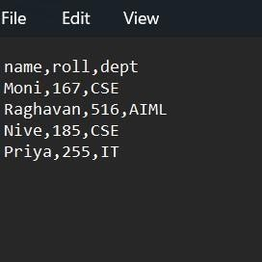

**Addittohadoopusing–put command:**

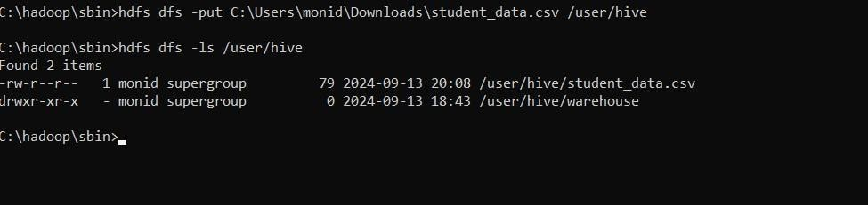

**AddDatatotheTABLE:**

Runthe**LOADDATALOCALINPATH**command:

LOADDATAINPATH'/user/hive/student_data.csv'INTOTABLEstudents_table;

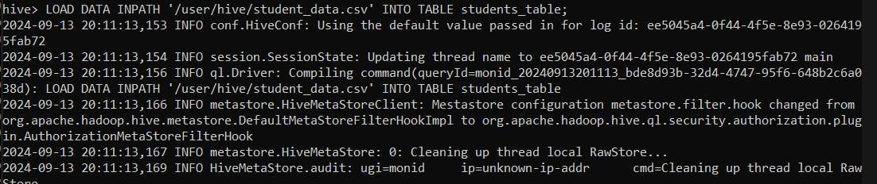

**ListHiveTablesandData:**

Toshowalltablesinaselecteddatabase,usethefollowing statement:

SHOWTABLES;

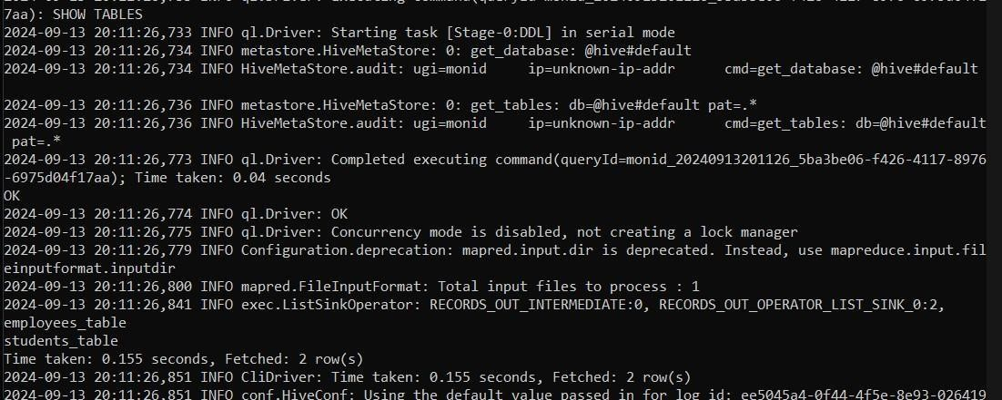

Todisplaytabledata,usea**SELECT**statement.Forexample,toselecteverythinginatable,run:

SELECT*FROMstudents;

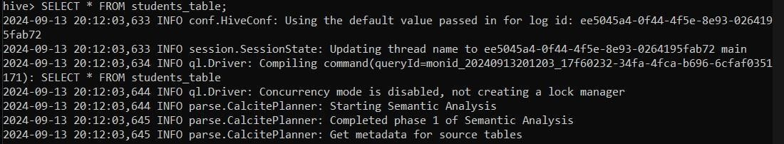

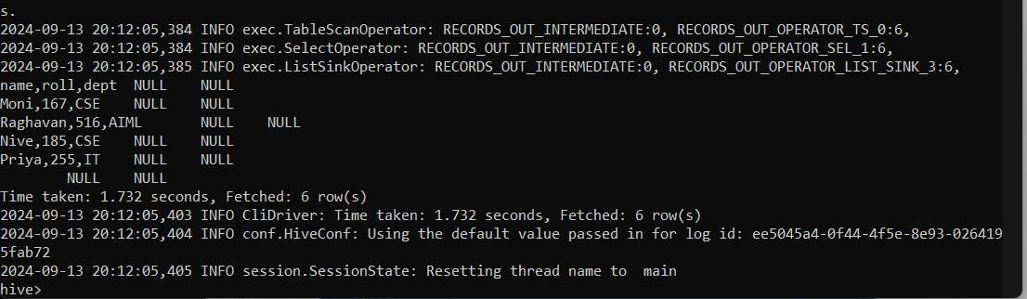

**Result:**

Thus,tocreatetablesinHiveandwritequeriestoaccessthedatainthetablewascompleted successfully.